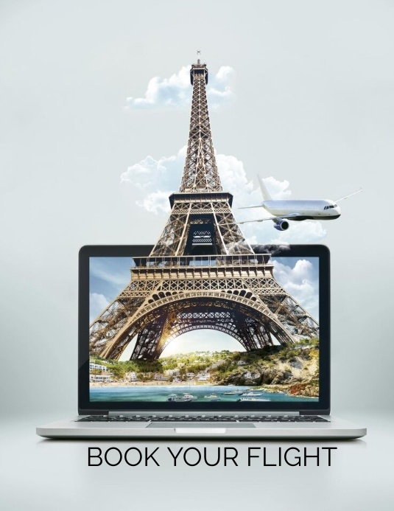

**By**

**PRIYA SANTHOSH KUMAR**

Table of Contents

Topic of figures 3

1. Introduction 4

1.1 Account Creation and Login 4

2. Searching for Flights 5

3. Selecting Flights 6

4. Passenger Information 8

5. Seats and Meals 11

6. Pre-Booking Process 13

7. Post-Booking Process 14

# Topic of figures

Figure 1 5

Figure 2 6

Figure 3 7

Figure 4 8

Figure 5 9

Figure 6 10

Figure 7 11

Figure 8 12

Figure 9 13

# Introduction

MakeMyTrip is an online travel platform that allows users to book flights, hotels, and other travel-related services. This user manual focuses on the flight booking process.

## 1.1 Account Creation and Login

Step 1: Visit this website [https://www.makemytrip.com/.](https://www.makemytrip.com/)

Step 2: If you do not have an account, click on "Sign Up" and provide the required details to create an account.

Step 3: If you have an account, click on "Log In" and enter your credentials to log in.

# 2. Searching for Flights

Step 1: After logging in, enter your departure and arrival cities, travel dates, and number of passengers.

Step 2: Select the trip type one way, round trip or multiple.

Step 3: Select the fare tpe.

Step 4: Click on "Search" to initiate the flight search.

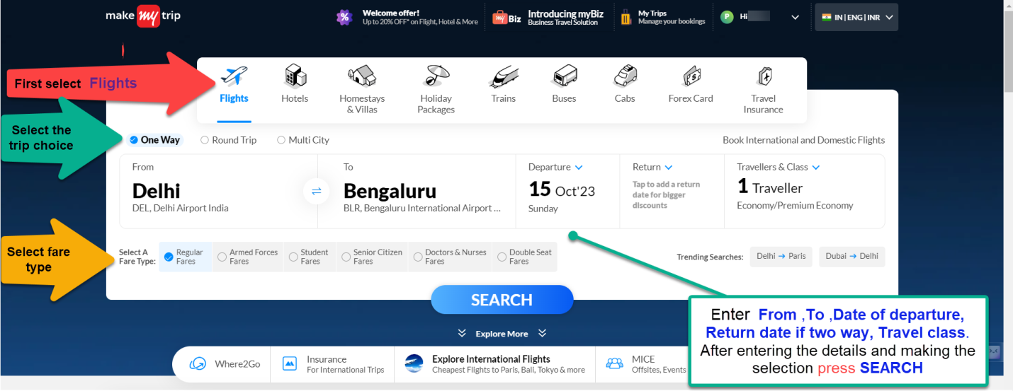

Figure

# 3. Selecting Flights

Step 1: Review the list of available flights based on your search criteria.

Step 2: Choose the desired flight based on your preferences, such as timing and price.

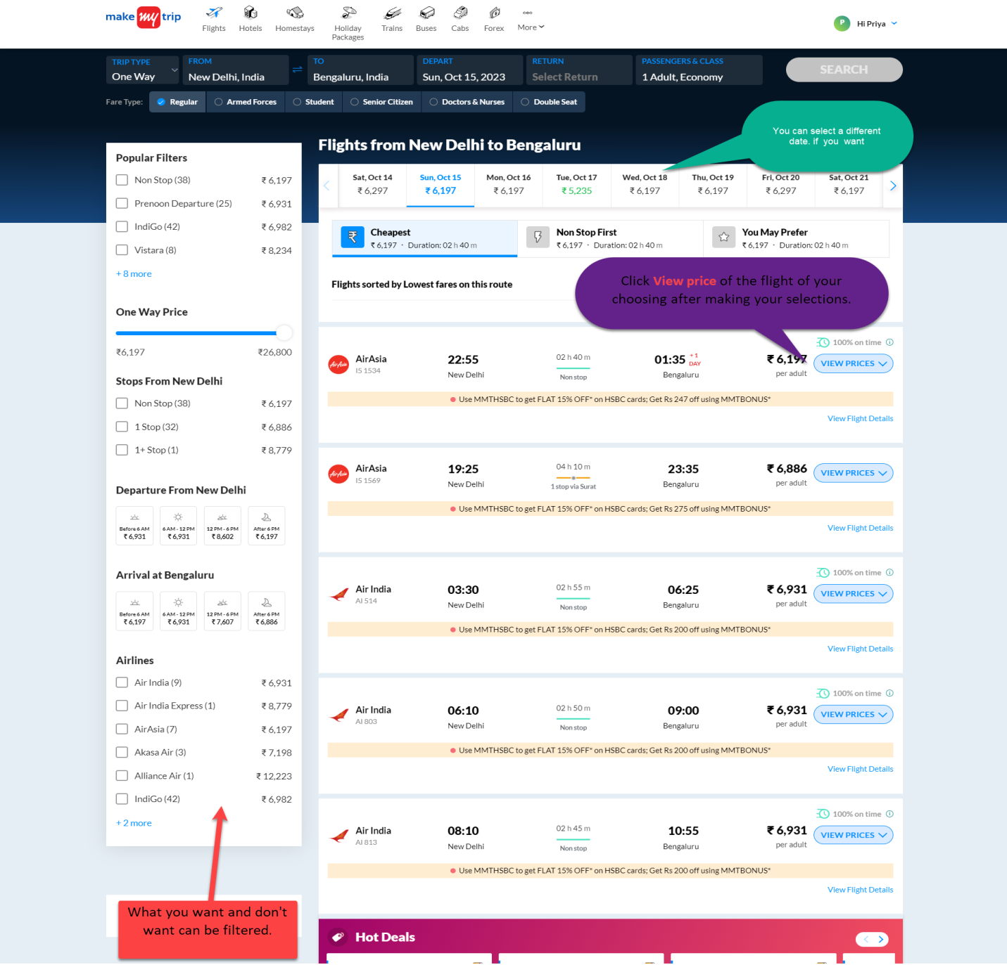Step 3: Click on "VIEW PRICE" to proceed with the flight selection.

Figure

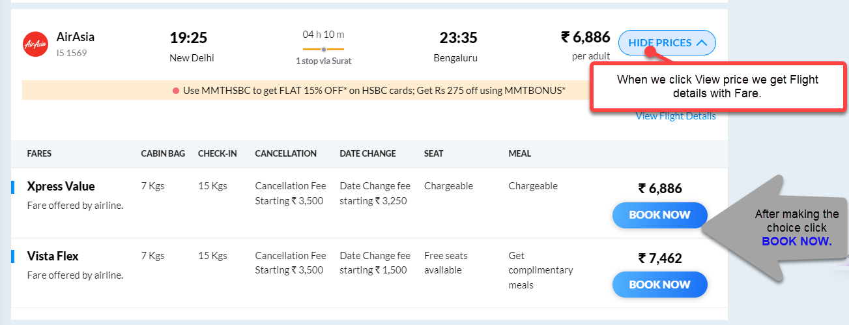 Step 4:Choose the desired flight and click “BOOK NOW”

Figure

# 4. Passenger Information

Figure

Step 1: Check the face summary and booking details for accuracy, as well as the cancellation refund policy.

Step 2: Enter the required passenger details, including names, contact information, and any special requests.

Step 3: After entering the details click on "Continue”.

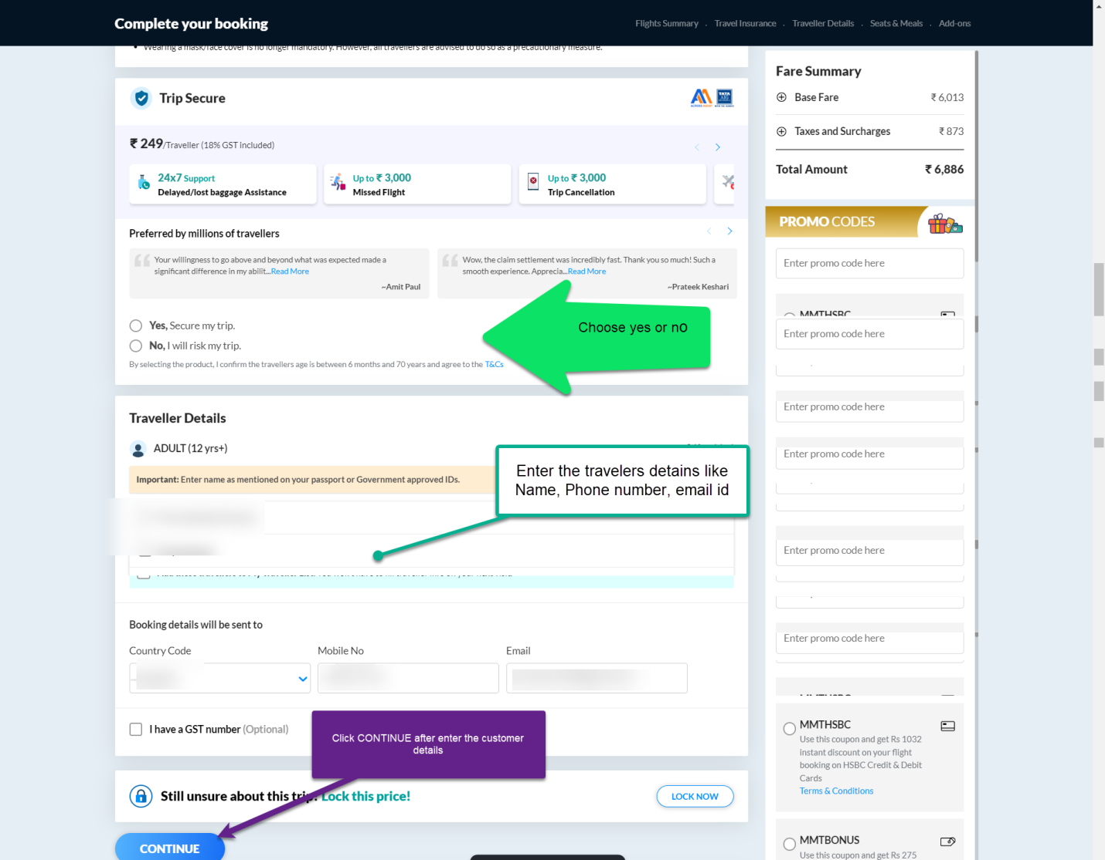

Figure

Step 5: Review the information and click on "Continue”.

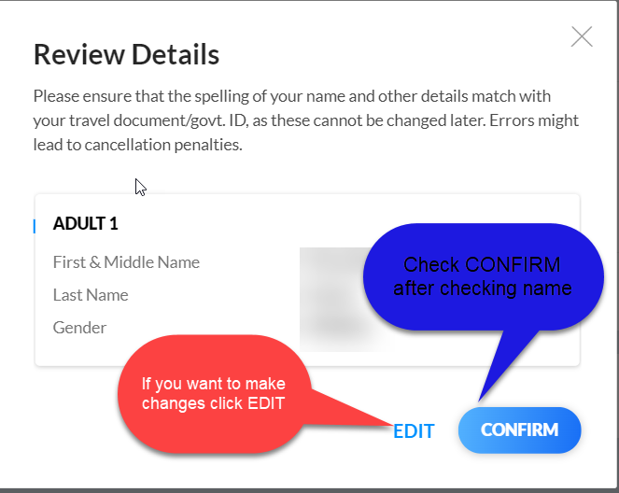

Figure

# 5. Seats and Meals

Step 1: Select seat of your choice and click “CONTINUE”

Figure

Step 2: Select meal of your choice and click “CONTINUE”.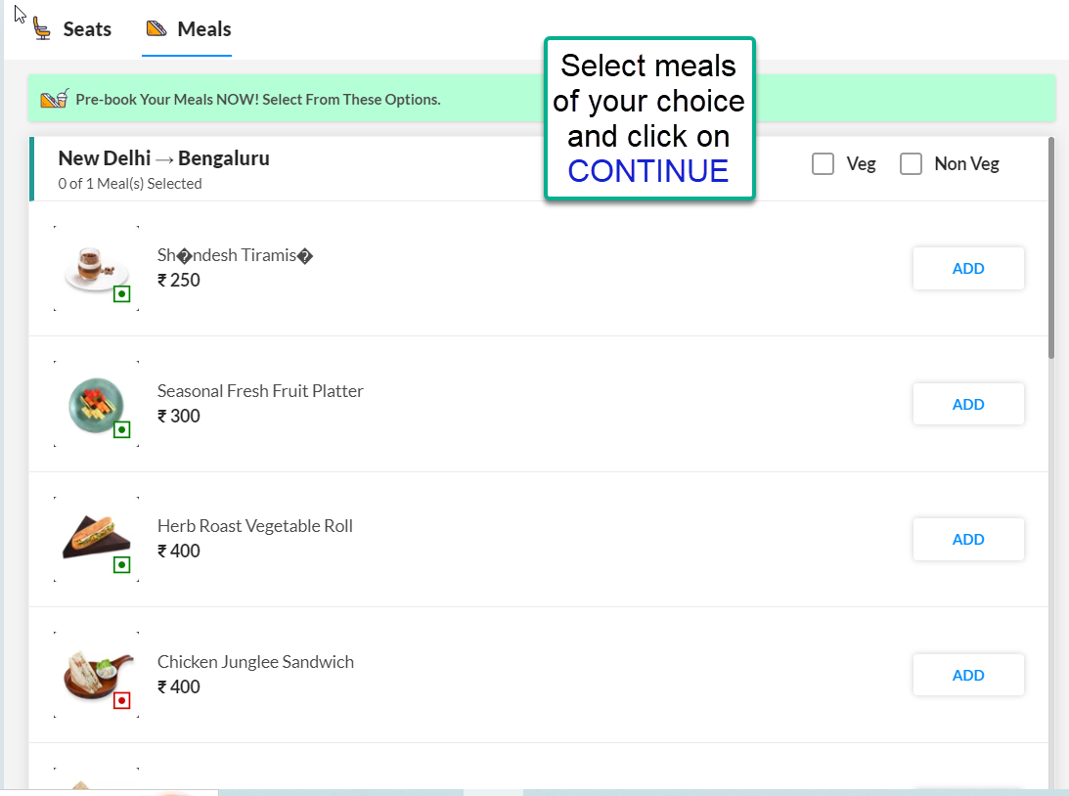



Figure

# 6. Pre-Booking Process

Step1: Validate all the information and select additional options you want

Step2: Click “PROCESS TO PAY” to complete the payment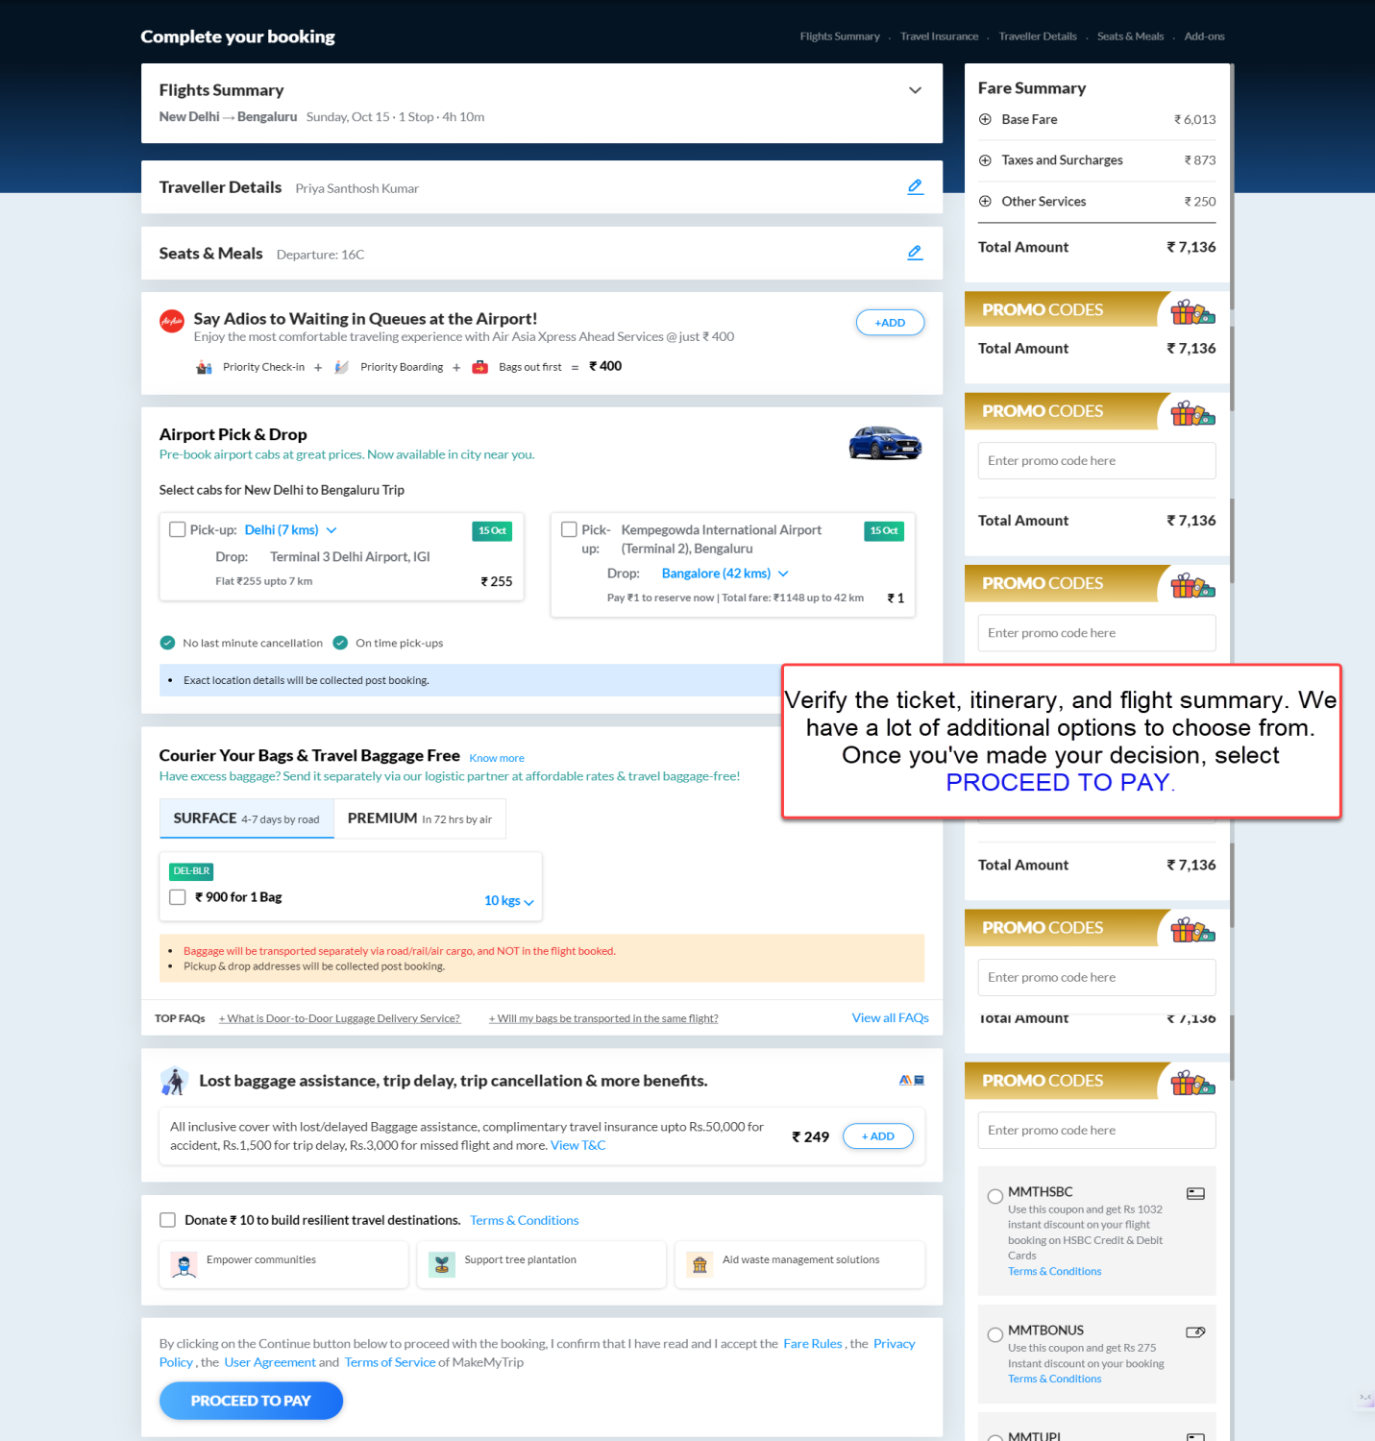.

Figure

# 7. Post-Booking Process

Step 1: Check your email for the booking confirmation and e-ticket.

Step 2: Review the flight details and ensure accuracy.

Step 3: Contact MakeMyTrip support for any changes or inquiries regarding your booking.